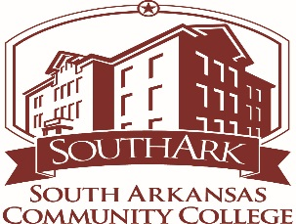
SOUTH ARKANSAS COMMUNITY COLLEGE
2018 JEANNE CLERY
ANNUAL CAMPUS SECURITY AND
FIRE SAFETY REPORT
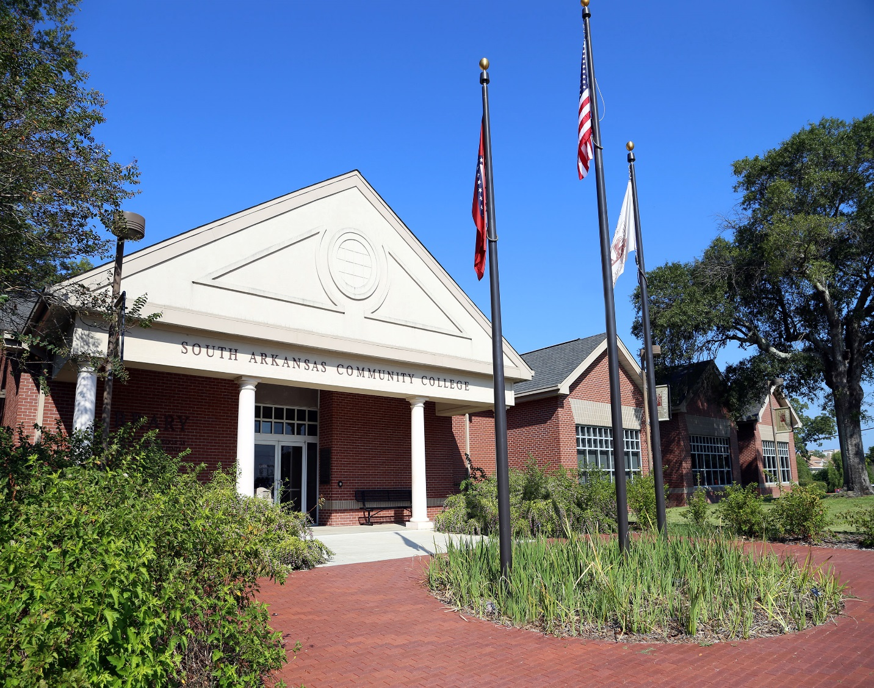

Message from Public Safety

We want to thank you for taking the time to read this year’s Annual Campus Security and Fire Safety Report. This report is designed to provide you with valuable information regarding security and fire safety on South Arkansas Community College (“SouthArk”) campus (for purposes of this report the term “campus” is used to include the East and West campuses in El Dorado and the Warren campus location. In addition to outlining the details of the many safety programs South Arkansas Community College offers its community members, the report also contains statistical information regarding reported crimes and fire initiatives for our campus.

The safety you experience on campus is due to the combined efforts of many different departments and individuals. Safety is a collective responsibility, and we rely on every single member of our school to contribute to the security of our school by using a commonsense approach and reporting suspicious activity when observed. The level of support we receive from our community members is critical to the success of the outcome. It is our duty as a department to maintain your trust. Safety is enhanced internally by our colleagues on our Campus Safety Committee that includes members from both SouthArk’ s East and West campuses along with SouthArk Warren campus, Behavioral Response Teams, and our health and safety training programs.

The SouthArk Campus Public Safety Department is primarily responsible for developing services, programs, and strategies for maintaining a safe campus. For us to meet this goal, the department focuses mainly on four functions:

First is a strong partnership with and service to the campus community. We recognize that we exist to provide a service-oriented department and support the idea that all relationships require trust and constant nurturing. We are committed to the philosophy of community-oriented public safety and problem-solving. By utilizing officers to serve as liaisons with various sections of the campuses, we can service the individualized needs of each school.

Second, a significant focus of the department is crime prevention and safety related programming to promote individual responsibility and community safety. The department offers a wide range of training opportunities that are presented throughout the academic school year.

Third, focusing on emergency management planning which requires a comprehensive approach to preventing, preparing for, responding to, and recovering from emergency situations. We take a proactive approach to planning for emergencies by collaborating not only with the entire campus community but with outside agencies such as the El Dorado Police Department, the El Dorado Fire Department, the Union County Sheriff’s Office, the Union County Office of Emergency Management, the Arkansas State Police, the Union County Health Department.

Lastly, the department is charged with the monitoring the Student Code of Conduct for South Arkansas Community College. This function is essential to maintaining an environment that is safe and conducive to learning.

We hope you find this report informative and helpful. If you have questions or would like further information, please contact our department.

Executive Summary

This document provides the mandated information necessary for compliance with the federal
Jeanne Clery Disclosure of Campus Security Policy and Campus Crime Statistics Act of 1998 (formerly the Crime Awareness and Campus Security Act of 1990). The statistical information provided herein is for the calendar years of 2016, 2017 and 2018.

Information given in this report is from January 1 to December 31 of each calendar year. This report also complies with the Higher Education Opportunity Act (HEOA) and includes new safety requirements in the following areas: hate crime reporting, emergency response and evacuation procedures, missing student notification, and fire safety information.

The primary intent of the Jeanne Clery Act is to provide accurate and timely safety information to the public, parents, current students, and potential students about the levels of crime and student alcohol and drug violations that occur on campus. This means ensuring all incident data available is complete and accurate for all individuals who inquire, enabling them to make informed decisions regarding their safety.

The information in this report has been sent to the U.S. Department of Education’s web-based Campus Safety and Security Data Analysis Cutting Tool which is available for the public to view. This report is also available on the SouthArk websites, and printed copies are available at the SouthArk Campus Public Safety Department which is located in the Health and Science Building room #248.

The Campus

A safe and secure educational environment is vitally important to parents, students, and employees. South Arkansas Community College recognizes this and seeks to provide a positive and safe atmosphere in which individuals can pursue educational opportunities. SouthArk has demonstrated this commitment through the development of policies and programs to help reduce crime. Some security measures are employed to protect the members of the campus community.

South Arkansas Community College’s main campus is located in Union County and serves higher education needs for the south-central part of Arkansas. SouthArk has an agreement with the city of El Dorado, to help maintain the Conference Center in the town of El Dorado. El Dorado has a population of approximately 18,539 as of 2013. Little Rock, the capital city of Arkansas, is 115 miles to the North of SouthArk also has a campus located in Warren, AR. The Warren campus, located in Bradley County serves a commuting population of approximately 40 students and does not afford or offer on-campus housing for any SouthArk student. Warren is the county seat for Bradley County with a county population of 11,508 as of the 2010 census.

With approximately 1800 SouthArk students and staff, on SouthArk campus’s, South Arkansas Community College offers a variety of academic programs and serves a commuting population and does not afford or offer on-campus housing for any SouthArk students.

SouthArk Campus Public Safety Department

South Arkansas Community College places a high priority on the safety of its students, employees, and guests. The SouthArk Public Safety Department strives to maintain an excellent safety record and employs security measures to ensure that all persons enjoy their time on campus.

The SouthArk Public Safety Department, provides services to all faculty, staff, students, and visitors on the main campus during regular operating hours from 7:00 am to 9:30 pm Monday thru Thursday and 8:00 am to 12:00 pm on Friday. The SouthArk Public Safety Department also provides security for all after hour’s activities that are scheduled on campus and at the El Dorado Conference Center.

The Warren campus regular hours of operations are Monday through Thursday from 8:00 am to 8:00 pm and Friday 8:00 am to 12:00 pm.

The public safety department is comprised of two full-time, ten part-time officers and one switchboard operator/Administrative Assistant. The department continually evaluates existing programs and looks for new ways to maintain and improve campus security. We value dedication, integrity, and professionalism in delivering our services, and employing a team approach to problem-solving whenever possible. Through innovation and creativity, we achieve a high standard of service to our campus community.

The department strives to provide the most secure surroundings possible and educates all students, employees, and visitors about their responsibility for campus safety. The department is responsible for all safety and security related issues on campus property and works in collaboration with federal, state, and local departments to enhance the level of law enforcement services available to the campus community.

The SouthArk Public Safety Department will continue to enhance current safety education and prevention programs throughout the year. The purpose of these programs is to ensure that the campus community receives information on safety, crime awareness, and on alcohol and drug abuse prevention. Professionally trained officers along with students and employees themselves equally share in the responsibility of making the campus a safe place to study, learn, and work. We believe that eliminating or minimizing criminal opportunities helps prevent crime.

The department provides numerous services to the campus community such as general patrols of the buildings and property, safety escorts, vehicle assistance (i.e., jumpstarts, lockouts, and flat tire changes), parking enforcement, event security, report investigations, safety training, and crime prevention and awareness.

South Arkansas Community College Mission Statement

South Arkansas Community College promotes excellence in learning, teaching, and service; provides lifelong educational opportunities; and serves as a cultural, intellectual, and economic resource for the community.

Public Safety Mission Statement

The mission of the SouthArk Public Safety Department is to provide a safe and secure educational environment that is conducive to learning through a professional department dedicated to deterring crime, educating and ensuring personal safety, and emergency management planning by formulating a partnership with the entire campus community.

South Arkansas Community College Vision Statement

The vision of South Arkansas Community College is building a vibrant community.

Public Safety Vision

The vision of SouthArk Public Safety Department is to provide excellent professional services to the campus community by maintaining a safe learning environment that supports academic freedom, respect for the individual, and the open exchange of ideas. We will work in partnership with all members of the campus community and outside agencies to provide quality services in all areas of public safety.

South Arkansas Community College Core Values

The college has identified six values statements that serve as guiding principles in fulfilling the Mission Statement.
1. Excellence in Education
We are committed to providing students access to a highly competent, innovative, and supportive faculty and staff; modern facilities equipped with current technology; and high-quality academic and occupational programs.
2. Student Learning
We are committed to providing support, respect, and encouragement, thereby enabling students to achieve their educational goals and develop skills for lifelong learning.
3. Contribution to the Community
We strive to serve the academic, occupational, and enrichment needs of the community; enhance its quality of life, and support economic development in South Arkansas.
4. Quality of Work Environment
Recognizing that everyone contributes to the learning process, we value each member of our college community; foster respect, trust, and support among faculty, staff, and students; encourage responsible, creative risk-taking and innovation; and recognize and reward exceptional performance and integrity.
5. Respect for Diversity
Believing that everyone should have an opportunity to learn and succeed, we value intellectual and cultural diversity in the classroom, in the workplace, and in the community.
6. Commitment to Accountability
We are committed to continuous evaluation of our institution to address the needs of the present and to meet the challenges of the future.
Public Safety Core Values

Professionalism
Our goal is to provide professional, practical, and quality service for the campus community.
Respect
The respect of the campus community should be earned by being professional and having much and courteous regard for everyone.
Integrity
Officers are expected to conduct themselves in a manner that is fair and ethical while exhibiting a high standard and leading by example.
Dedication
Our department is dedicated to providing the campus community with a safe and secure educational environment that is conducive to learning.
Excellence
Strive for personal and professional excellence, dedication to duty, and outstanding service for the campus community.

By following the values of PRIDE, we strive to serve the campus community the best way possible.

Phone and Emergency Contact Information

SouthArk West Campus Public Safety Department | extension 125 or 870-864-7125  Red Phone 870-866-9208
SouthArk East Campus Public Safety Department | extension 472 or  Red Phone 870-665-1908
SouthArk Warren Campus | 870-226-6920
Fire or Medical Emergency | 911
El Dorado Central Fire Commander | 870-881-4850
El Dorado Police Department | 870-863-4141
Union County Sheriff’s Department | 870-864-1990
Union County Office of Emergency Management | 870-864-1908
Warren Police Department | 870- 226-3703
Medical Center of South Arkansas | 870-863-2000
SouthArk Switchboard | extension 114 or 870-864-7114
Arkansas State Police | 870-777-4641
Poison Control Center | 1-800-376-4766
FBI (Little Rock Office) | 1-501-221-9100

Criminal Reporting at SouthArk Campus’s
Students and employees are strongly encouraged to report incidents of criminal conduct, suspicious behavior or emergencies to the SouthArk Public Safety Department along with the local police department. The SouthArk Public Safety Department should be notified to assist with the investigation and may assist in determining the necessity to call the police department. With such information, the department can take the necessary steps to help ensure the future safety of the campus by keeping an accurate record of the number of incidents that have occurred. Determining where there is a pattern of crime about a particular location, method, or assailant and alerting the campus community of potential danger are also benefits of such information. The SouthArk Public Safety Department has the responsibility to investigate all crimes which occur at the SouthArk Campus.

Health and Student Safety

Student Insurance
The college does not provide accident or health insurance for students. However, the college strongly recommends that students purchase health and accident insurance. The college will, if possible, refer students who wish to acquire such insurance to potential vendors.
Students who participate in clinical experience in health facilities off campus are provided liability insurance as a condition for admission to the clinical areas. The college will arrange for liability insurance, and assure that all students have liability insurance before being allowed to enter a clinical area. Contact appropriate health science program director for further information.

HIV or AIDS Virus
The college recognizes the impact of the Human Immunodeficiency Virus (HIV or AIDS Virus) on students and employees, both regarding the safety of the work environment and regarding potential infection. The college has established guidelines based on comprehensive medical and legal information. SouthArk employees and students with HIV infection, AIDS, or a positive HIV antibody test, whether symptomatic or not, will be allowed unrestricted activities as long as they are mentally and physically able to perform their job duties in a manner that does not pose a health or safety risk to themselves or others.

Smoking and Tobacco Products
Students will follow the APM policy on the use of tobacco products that can be found here APM Policy 2.04 Use of Tobacco Products

Weapons on Campus
Students will follow the APM policy regarding weapons on campus can be found here APM Policy 2.05 Weapons

Policies and Procedures for Campus Police
Policy Statement
SouthArk will comply with the Clery Act, Title IX, and the Violence Against Women Act by
- maintaining a daily crime log,
- Reporting criminal statistics as well as security policies and procedures in annual campus safety and security report.
- Enforcing the requirements of the Clery Act, Title IX, and the Violence Against Women Act.
When sexual/gender-based misconduct occurs, SouthArk will investigate, stop, prevent, and provide remediation as necessary to all parties involved and the college community at large

Rights of Members of the SouthArk Community about Sexual Misconduct
All employees, administrators, staff, visitors, and students have a right to be free from sexual harassment, sexual violence, and sexual discrimination. These rights mandate that everyone is held responsible for behaving professionally and lawfully on campus. SouthArk has a zero-tolerance policy for gender-based misconduct. Once an allegation of misconduct is reported to the appropriate official and probable cause exists, then an investigation of these allegations will take place, and sanctions may result if a violation of the policy is determined. The implementation of the policy against gender-based misconduct is an assurance that each violation will be investigated thoroughly and sanctioned. The following Clery Act policies and procedures are set forth to maintain consistent enforcement of this act and to comply with its reporting requirements. The policies and procedures also serve to guide faculty, staff, administrators, students, and other interested stakeholders in conducting themselves according to the Act while on campus.

- General Policies and Procedures Ensuring the Safety and Security of Campus Facilities
SouthArk is a public institution of higher education, and facilities on both East and West campuses are open to students, faculty, administration, staff, and the general public.
SouthArk is committed to providing a safe and secure learning environment for all patrons, but campus safety and security are dependent on cooperation among students and college employees. Students and staff are encouraged to report criminal conduct, violations of college policy, or suspicious activity to any campus administrator or security personnel and to file a report promptly when violations occur (see procedures under Section II. below).

Behavioral Review Team
A Behavioral Review Team (BRT) has been established to assist in dealing with situations that go beyond basic classroom management and present a threat to the general safety and wellbeing of the campus community. The BRT represents a campus-wide, collaborative commitment to ensure the safety of all students, staff, and faculty. Committee members serve to assess and investigate any reported concerns from the campuses or larger community and make appropriate determinations and referrals to facilitate student engagement and success. In pursuit of this mission, the BRT has developed a reporting and communications system whereby potentially dangerous situations are more likely to be detected, addressed, and communicated to appropriate parties before they escalate to more severe levels. Concerns should be directed to the office of the Vice President for Student Services.

Campus Security
For the safety of employees and students, the college provides uniformed campus police officers during all hours that the college is in operation. Individuals who are concerned about their immediate safety should call 911 or via a “blue-light” emergency phone in campus parking lots (see below). Otherwise, they should contact campus police by phone at (870) 864-7125, via a red security phone in select campus buildings, by dialing 999 from a campus phone, or by going to the security office (HSC248) located in the Health and Science building the second floor. Students are required to report all incidents of campus accidents or crime to campus police.

On-Campus Security Phones
Red security phones have been installed on the West campus in the hallways of the Whitfield classroom building, the Computer Technology Building, the El Dorado Conference and Student Center, the library (one in the gallery and one at the front desk); and on the east campus in the atrium of the Center for Workforce Development and in the student lobby of the McGehee Building and the AMTC building. When the receiver is picked up, a call is automatically routed to a cell phone carried by the on-duty Police Officer’s or Public Safety staff, allowing immediate contact with Campus Police or Public Safety.

“Blue-light” emergency phones have been installed in the following parking lots: West Campus Main (between the Library and Computer Technology building), Health Sciences building, and Conference and Student Center, as well as the East Campus Main parking lot between the McGehee Classroom Building and the Workforce Development Building. These phones are direct lines to the 911 center.

Video Surveillance
Numerous video surveillance cameras are located in common areas throughout the SouthArk campuses. These include cameras at entryways and parking lots. The cameras are monitored and recorded digitally to help enhance safety for students, faculty, and staff while on our campus. The system is set up in common areas across the school and has both indoor/outdoor cameras that are often vandal proof and infrared.
The system is battery backed up and continues surveillance even if a campus-wide power loss occurs.
The College considers a reasonable expectation of privacy at every camera location on campus. Typically, cameras are installed in pedestrian throughways, building egresses, parking lots, and facilities.
Cameras are only installed where an individual’s expectation of privacy is generally limited.

- Policies and Procedures for Reporting Crimes, Accidents, and Other Incidents
Members of the SouthArk community should report criminal activity, accidents, and violations of college policies to the Campus Police office in person at HSC248 in the Health and Science Building or by calling (870) 864-7125, (870) 866-9208 or (800) 955-2289. Campus Police personnel are on duty during the regular hours of operation Monday-Thursday from 8:00 a.m.-9:00 p.m. and Friday from 8:00 a.m. to 12 p.m. additionally, police personnel is on campus during the weekend when classes, scheduled facility openings or events are taking place. SouthArk campus community members may also report crimes to the El Dorado Police Department (EPD) at (870) 881-4141. If individuals on campus notify EPD, they should notify Campus Police also. EPD works cooperatively with SouthArk’s Police personnel and the administration to provide prompt assistance if a crime should occur on campus. Campus Police or other staff will make immediate contact with EPD in cases of emergency.

Filing Internal Reports: In addition to notifying Campus Police, victims of crime or witnesses to criminal activity, accidents, or violations of college policies also should submit a formal report with the office of Public Safety. A victim or witness can also make a confidential statement to the office of the Vice President for Student Services (SouthArk Student Center, Room 263, (870) 864-7128 or to a college counselor at (870) 864-7235.

Crime report forms, accident report forms, and incident report forms are available in the Campus Police office, the library, and in the office of the Vice President for Student Services on the West Campus. For any completed report to be official, it must be signed by Campus Police or the El Dorado Police Department. Employees of the college are responsible for calling for outside assistance if deemed necessary.

Protecting “Whistleblowers” from Retaliation
Students are protected under the Arkansas Whistle-Blower Act as described in the APM policy on
whistleblowers (6.12), which can be found here 6.12 Whistleblower Act

External Reporting of Crime Data
The Office of Student Services receives all crime, accident, and incident report forms and works with the Director of Campus Police and other campus personnel to make appropriate reports to state and federal officials. Federal law requires that data must be collected on the following criminal offenses: murder, sex offenses robbery, aggravated assault, burglary, motor vehicle theft, manslaughter, arson, harrassment, sexual assault, domestic violence, dating violence, and stalking. Also, the college is required to maintain statistics on the number of arrests made for the following crimes occurring on campus: liquor law violations, drug abuse violations, and weapons possessions. Crime statistics are reported in the college catalog (see below), and crime logs are available upon request from the Campus Police office.

West campus

Criminal Offenses Reported | 2014 | 2015 | 2016 | 2017 | 2018
Murder | 0 | 0 | 0 | 0 | 0
Sex Offenses | 0 | 0 | 1 | 0 | 0
Robbery | 0 | 0 | 0 | 0 | 0
Aggravated Assault | 2 | 0 | 0 | 0 | 0
Burglary | 1 | 0 | 3 | 1 | 0
Motor Vehicle Theft | 0 | 0 | 0 | 0 | 0
Arson | 0 | 0 | 0 | 0 | 0
Manslaughter | 0 | 0 | 0 | 0 | 0
Hate Crimes | 0 | 0 | 0 | 0 | 0
Arrests for Violations | 0 | 0 | 0 | 0 | 0
Referrals | 0 | 0 | 0 | 0 | 0
Liquor Law | 1 | 0 | 0 | 0 | 0
Drug Abuse | 0 | 0 | 0 | 0 | 0
Weapons Possessions | 0 | 0 | 0 | 0 | 0

East Campus
Criminal Offenses Reported | 2014 | 2015 | 2016 | 2017 | 2018
Murder | 0 | 0 | 0 | 0 | 0
Sex Offenses | 0 | 0 | 0 | 0 | 0
Robbery | 0 | 0 | 0 | 0 | 0
Aggravated Assault | 0 | 0 | 0 | 0 | 0
Burglary | 0 | 0 | 0 | 0 | 0
Motor Vehicle Theft | 0 | 0 | 0 | 0 | 0
Arson | 0 | 0 | 0 | 0 | 0
Manslaughter | 0 | 0 | 0 | 0 | 0
Hate Crimes | 0 | 0 | 0 | 0 | 0
Arrests for Violations | 0 | 0 | 0 | 0 | 0
Referrals | 0 | 0 | 0 | 0 | 0
Liquor Law | 0 | 0 | 0 | 0 | 0
Drug Abuse | 0 | 0 | 0 | 0 | 0
Weapons Possessions | 0 | 0 | 0 | 0 | 0
Warren Campus
Criminal Offenses Reported | 2014 | 2015 | 2016 | 2017 | 2018
Murder | 0 | 0 | 0 | 0 | 0
Sex Offenses | 0 | 0 | 0 | 0 | 0
Robbery | 0 | 0 | 0 | 0 | 0
Aggravated Assault | 0 | 0 | 0 | 0 | 0
Burglary | 0 | 0 | 0 | 0 | 0
Motor Vehicle Theft | 0 | 0 | 0 | 0 | 0
Arson | 0 | 0 | 0 | 0 | 0
Manslaughter | 0 | 0 | 0 | 0 | 0
Hate Crimes | 0 | 0 | 0 | 0 | 0
Arrests for Violations | 0 | 0 | 0 | 0 | 0
Referrals | 0 | 0 | 0 | 0 | 0
Liquor Law | 0 | 0 | 0 | 0 | 0
Drug Abuse | 0 | 0 | 0 | 0 | 0
Weapons Possessions | 0 | 0 | 0 | 0 | 0

Reporting of Registered Sex Offenders
Registered sex offenders who apply for enrollment in classes at the College are required to notify Campus Police. Anyone interested in a list of registered sex offenders may contact the Detective Division of the El Dorado Police Department or the SouthArk Campus Police office.

- Law Enforcement Policies

Working Relationship with Local Police
SouthArk’s administration and police personnel work with the El Dorado Police Department
(EPD) to provide reports as well as a prompt and collaborative response if crimes occurring on campus warrant the assistance of local police. When incidents that have occurred on SouthArk’s East or West Campus, call for an investigation by the EPD, SouthArk may request documentation.
When incidents that have occurred on SouthArk’s Warren Campus, call for an investigation by the Warren PD, SouthArk may request documentation.

Authority of Police Personnel
SouthArk police personnel report to the Vice President of Finance and Administration and Associate Vice President of Administration. Although they have the power of arrest, in crisis situations, police personnel are expected to follow established procedures for contacting EPD for the West and East campus. On the Warren campus they will need to contact Warren PD for assistance.
- Programs to Inform Students and Employees about Crime and Crime Prevention
The college employs full- and part-time police personnel to monitor activity and provide campus protection. Police personnel is authorized to handle any incidents that threaten the welfare or security of students or staff. Police personnel are informed of procedures to follow in cases of emergency and are instructed to report all incidents to appropriate authorities.

Awareness and Prevention
The need for students to be cautious and aware of the potential for crime in general and sexual offenses, in particular, is discussed at orientation. Also, the college’s counselor conducts seminars and workshops covering topics associated with crime, substance abuse, and sexual assault during the academic year. Examples of such workshops include, but are not limited to, the following:
- First-time College Student Workshop
- Single Parent Workshop
- Adult Survival Workshop
- Date Rape and Crime Prevention Workshop

Posters and announcements placed on bulletin boards and in campus publications are used to alert students and staff about crime prevention and precautions that should be taken.
Timely Warning Notice
In case of emergency, the college will use email, the college website, the emergency calling system, and the Alertus communications system, as appropriate, to communicate serious crimes, violations, and other situations on campus that have an impact or potential impact on the safety and wellbeing of the campus community.

Emergency Response, Notification, and Testing Policy
SouthArk has distributed to every employee and every classroom on campus a copy of the South Arkansas Community College Quick Guides Emergency Handbook, which details appropriate responses in the event of campus emergencies. The college will conduct drills once annually to test the plan. Also, the South Arkansas Community College Administrative Policy Manual (APM) includes an “Emergency Communications Plan” (5.21), which may be accessed on the college website. This plan has been formulated to provide a guideline for internal and external communications during an emergency situation at SouthArk. For this plan, an emergency event could result from the following cause(s):

Earthquake | Suicide/Sudden death
Flood | Serious incident staff/students
Fire | Pandemic
Chemical explosion | Other medical crises
Toxic leak | Robbery
Terrorist attack/bomb threat | Occupation of buildings
Extreme weather/tornado | Hostage-taking/kidnapping
Energy blackout  Armed Intruder | Missing person(s)

Once an emergency situation has been identified, the ranking college administrator, upon consultation with the appropriate personnel and in concert with any applicable city, county, state, or federal entities, select and direct a situation-appropriate response. Depending upon the nature of the emergency, the college may suspend or dismiss classes; evacuate one or more buildings; direct students, faculty, and staff to take shelter; or close one or both of the campuses.
- Campus-Wide Emergency Communications
The APM Policy on the Emergency Communications Plan can be found here APM Policy 5.21 Emergency Communications Plan

- Fire on Campus
A fire on campus could destroy property and endanger lives. Students who discover a fire should
- Sound the alarm or call 911 immediately
- Inform others of potential danger
- Leave the building immediately and direct the fire department to the fire
- Never enter a burning building

Evacuation plans are posted in all campus buildings.

- Missing Persons
Members of the campus community should report missing persons to Campus Police. When Campus Police becomes aware of a missing person among the campus community, personnel will investigate on campus, then contact the El Dorado Police Department and the Union County Sheriff’s Office with a welfare concern, including a description of the person so they can put out a BOLO (“Be On the Look-Out”) alert for the individual. Personnel will continue to search on campus, investigate known facts, and collaborate with local law enforcement agencies until the case is resolved.

- How to Deliver Emergency Messages to Students
The student advising coaches or Enrollment Services should be contacted in case of an external, non-campus emergency involving a member of the student body. Classes may not be disturbed except in cases of extreme emergencies.

- Drug and Alcohol Policy
Drug-Free Workplace
To ensure a drug-free working and learning environment at SouthArk, the college has established a drug and alcohol policy for employees and students.

Policy Statement
SouthArk prohibits the unlawful possession, use, manufacturing, dispensing or distribution of illicit drugs and alcohol by employees and students of the college on college property or as a part of its activities, nor shall employees or students use prescription drugs or alcohol if such use impairs effective performance of their responsibilities. Governor’s Policy Directive Number Five notes, “Use of alcoholic beverages or controlled substances is strictly prohibited during working hours and shall be grounds for immediate dismissal.”

Local, State, and Federal Laws
Employees and students are expected to abide by local, state, and federal laws regarding the unlawful possession, use, or distribution of illicit drugs and alcohol. The Administration is authorized to impose disciplinary action up to and including suspension or expulsion upon those who violate this policy. Also, if circumstances dictate, local law enforcement authorities will be contacted...
- Drug Awareness and Reporting
Reporting and Follow-up of Drug-Related Crimes and Abuse
Individuals who observe violations of the SouthArk drug policy should report the information immediately to any college official or Campus Police. All reports eventually should be channeled to the Campus Police staff for investigation and follow-up. If an incident requires the immediate attention of campus or local authorities, then the college official should contact local law enforcement authorities immediately.

Drug and Alcohol Counseling
To inform employees and students about the effects of drugs and alcohol, the college will provide educational programs, counseling, and activities designed to meet the employees’ and students’ needs. The college has established a collaborative relationship with South Arkansas Regional Health Center for counseling, testing, and treatment.

Support and Assistance
In El Dorado, assistance for alcohol and substance abuse problems can be obtained at South Arkansas Substance Abuse at 100 Hargett Drive, or by calling (870) 881-9301 (line available 24 hours a day).

Enforcement
Disciplinary action will be taken against employees, and students found guilty of the unlawful possession, use, manufacturing, dispensing or distribution of illicit drugs and alcohol on college property or as a part of any of its activities. Complete information regarding Standards of Student Conduct can be found in the college catalog. Should a student be charged with any violation of the college Drug Policy or another standard of conduct, Campus Police will investigate and report findings to the Vice President for Student Services, who will be responsible for initiating student disciplinary action as necessary after
- Meeting with the student
- Determining the nature of the violation, and
- Allowing the student an opportunity for a hearing
If circumstances dictate, the appropriate local law enforcement agency will be contacted
The administration may impose disciplinary action, including, but not limited to, the following:
A. Dismissal – Termination of employment with or enrollment in the college.
B. Probation – An official warning that the employee’s or student’s conduct violates the college’s policy. Probation may be imposed for varying periods of time with restrictions and behavior guidelines as a condition of continued employment or enrollment. These conditions may include drug and alcohol abuse counseling.
C. Letter of Reprimand – A letter, of which a copy will be placed in the employee’s or student’s file, stating that the conduct is not acceptable to the college.

- Sexual Misconduct
Policy Regarding Sexual Assault on Campus

SouthArk will not tolerate any action involving a student or employee that is intended or assault is a violation of an individual’s human rights and dignity. All reports or complaints concerning crimes of this nature will be vigorously pursued in conjunction with local law enforcement authorities.

Procedures to Follow if a Sexual Offense Occurs on Campus
Anyone who is subjected to offensive or criminal sexual behavior or assault is encouraged to take action through the established informal or formal channels within the college.
Informal procedure/channel: The victim should seek assistance from any campus police person, faculty member, supervisor, or counselor. Appropriate referrals and connections will be made on behalf of the victim.
Formal procedure/channel: The victim should report the offense to college police personnel immediately; an investigation into the incident will follow. In all cases, efforts should be made to preserve any evidence that might be used to apprehend and convict the accused assailant. In all cases, the rights and privacy of victims and alleged violators will be considered, and actions will be taken accordingly.

Disciplinary Proceedings/Due Process/Privacy
Sex crimes are considered major offenses punishable by both the college and the courts. Crimes involving sexual offenses, which are reported through formal or informal procedures, will be investigated by the college security personnel who will ensure that all rights of both the accuser and accused are protected. These rights include, but shall not be limited to, discreet and professional handling of all matters concerning the alleged incident, and the opportunity to have others present during a campus disciplinary hearing.

If charges are filed, it will be the responsibility of the Vice President for Student Services (VPSS) to arrange for due process and documentation of all campus proceedings. In all cases, victims will be informed of their options for reporting crime and for receiving assistance if such is needed or desired. Both the accuser and the accused will be made aware of the outcomes of formal proceedings.

Employees found guilty of such offenses will be subject to a written warning, a suspension without pay, and a discharge, depending upon the circumstances of the specific incident. The referral will be made to local law enforcement authorities for further action if this is appropriate.
Students found guilty of sexual offenses will be subject to disciplinary action up to and including suspension or expulsion from the college, depending on the circumstances of the specific incident, and will be referred to law enforcement authorities for further action if appropriate.

Victim Assistance
The VPSS is responsible for referring victims of sexual offenses to appropriate college personnel and/or to agencies in the community that handle such situations. The Victim Assistance Program, established through the local court system, offers assistance and support to victims at no cost.
The Victims Assistance contact number is (870) 863-8762. Assistance is also available through the Union County Rape and Family Violence Center at (870) 862-0929.
SouthArk will change a victim’s academic situation as necessary after an alleged sexual offense has occurred, or as requested by the victim. Such changes could include, but would not be limited to, a change in the student’s class schedule.

Sexual Harassment
SouthArk will not tolerate sexual harassment by any of its students or employees, including its managerial and supervisory employees.
It is a violation of federal law and the rules, regulations, and policies of SouthArk for any employee or student to sexually harass another employee or student. By:
(1) making unwelcome sexual advances or requests for sexual favors or other verbal or physical conduct of a sexual nature, as a condition of any employee’s employment or student’s enrollment, (2) making submission or rejection of such conduct the basis for employment decisions affecting the employee or decisions concerning a student.
(3) creating an intimidating, hostile, or offensive working environment by such conduct.
Anyone who is subjected to offensive sexual behavior is encouraged to pursue the matter through the established informal or formal grievance procedures of the college. All incidents should be reported to the VPSS immediately, and the college will investigate all complaints. Any person who has been found by SouthArk to have sexually harassed another person shall be subjected to appropriate punishment.
Sexual harassment is a major offense, and employees found guilty will be subject to a written warning, a suspension without pay, or a discharge, depending upon the circumstances of the sexual harassment incident. Students that are found guilty will be subject to disciplinary action up to and including suspension or expulsion from the college.

Glossary
Definitions [from the Jeanne Clery Act Training Manual]
Annual Security Report (ASR): Annual report with statements of campus security policy and crime statistics provided to current and prospective students and employees under the Clery Act by October 1st of each year.
Campus Security Authority (CSA): A campus policy or security official or another official with significant responsibility for campus and student activities. A CSA has responsibilities under Clery to report information for timely warnings and crime statistics.
Clery Act: Jeanne Clery Disclosure of Campus Security Policy and Campus Crime Statistics Act. All public and private institutions of postsecondary education participating in federal student aid programs are subject to it.
ED: U.S. Department of Education. ED is responsible for implementing and enforcing the federal Jeanne Clery Act.
Family Educational Rights and Privacy Act (FERPA): FERPA, also known as the Buckley Amendment, is a federal law that protects the privacy of student education records. The law applies to all schools that receive funds under an applicable program of the U.S. Department of Education.
Hierarchy Rule: A principle used by the FBI’s Uniform Crime Reporting program and adopted by Clery that specifies that only the most serious crime in a multi-crime situation is reported.
NIBRS-National Incident-Based Reporting System. Next generation UCR program (see below).
OVC: Created in 1983, the Office of Victims of Crime (OVC) is a federal office within the U.S. Department of Justice (USDOJ) that provides federal funds to support victim assistance and compensation programs around the country and advocates for the fair treatment of crime victims.
Clery Center: Clery Center for Security on Campus, Inc. is a non-profit (501)(c)(3)) organization whose mission is to prevent violence, substance abuse and other crimes in college and university campus communities across the United States, and to assist the victims of these crimes compassionately.
UCR: The Uniform Crime Reporting (UCR) Program was conceived in 1929 by the International Association of Chiefs of Police to meet a need for reliable, uniform crime statistics for the nation.
Murder/Non-Negligent Manslaughter: the willful (non-negligent) killing of one human being by another. Note: Deaths caused by negligence, attempts to kill, assaults to kill, suicides, accidental deaths, and justifiable homicides are excluded.
Negligent Manslaughter: the killing of another person through gross negligence.
Robbery: the taking or attempting to take anything of value from the care, custody, or control of a person or persons by force or threat of force or violence and by putting the victim in fear.
Aggravated Assault: an unlawful attack by one person upon another to inflict severe or aggravated bodily injury. This type of assault usually is accompanied by the use of a weapon or by means likely to produce death or great bodily harm. It is not necessary that injury results from an aggravated assault when a gun, knife, or other weapon is used which could or probably would result in a serious potential injury if the crime were completed.
Burglary: The unlawful entry of a structure to commit a felony or a theft. Unlawful entry with intent to commit a larceny or a felony; breaking with intent to commit a larceny; housebreaking; safecracking; and all attempts to commit any of those above.
Motor Vehicle Theft: The theft or attempted theft of a motor vehicle. (Classified as motor vehicle theft in all cases where automobiles are taken by persons not having lawful access, even though the vehicles are later abandoned-including joy riding)
Arson: the willful or malicious burning or attempt to burn, with or without intent to defraud, a dwelling house, public building, motor vehicle or aircraft, or personal property of another kind.
Weapon Law Violations: The violation of laws or ordinances dealing with weapon offenses, regulatory in nature, such as manufacture, the sale of deadly weapons; carrying deadly weapons, concealed or openly; furnishing deadly weapons to minors; aliens possessing deadly weapons; all attempts to commit any of those above.
Drug Abuse Violations: Violations of state and local laws relating to the unlawful possession, sale, use, growing, manufacturing, and the making of narcotic drugs. The relevant substances include opium or cocaine and their derivatives (morphine, heroin, codeine); marijuana; synthetic narcotics (Demerol, methadone); and dangerous non-narcotic drugs (barbiturates, Benzedrine).
Liquor Law Violations: The violation of laws or ordinances prohibiting: the manufacture, sale, transporting, furnishing, possessing of intoxicating liquor; maintaining unlawful drinking places; bootlegging; operating a still; furnishing liquor to a minor or intemperate person; using a vehicle for illegal transportation of liquor; drinking on a train or public conveyance; all attempts to commit any of the aforementioned. (Drunkenness and driving under the influence are not included in this definition).

Definitions & Terms (from the Violence Against Women Act)
1. Domestic violence: includes felony or misdemeanor crimes of violence committed by a current or former spouse or intimate partner of the victim, by a person with whom the victim shares a child in common, by a person who is cohabitating with or has cohabitated with the victim as a spouse, by a person similarly situated to a spouse of the victim under the domestic or family violence laws of the jurisdiction receiving grant monies, or by any other person against an adult or youth victim who is protected from that person’s acts under the domestic or family violence laws of the jurisdiction.
2. Dating violence: violence committed by a person:
(A) Who is or has been in a social relationship of a romantic or intimate nature with the victim; and
(B) Where the existence of such a relationship shall be determined based on a consideration of the following factors:
(i) The length of the relationship.
(ii) The type of relationship
(iii) The frequency of interaction between the persons involved in the relationship.
3. Stalking: engaging in the course of conduct directed at a specific person that would cause a reasonable person to:
(A) Fear for his or her safety or the safety of others; or
(B) Suffer substantial emotional distress

Definitions of Sex Offenses [from the National Incident-Based Reporting System Edition of the Uniform Crime Reporting Program]
Sex Offense: any sexual act directed against another person, forcibly and against that person’s will; or not forcibly or against the person’s will where the victim is incapable of giving consent.
Two Categories of Sex Offenses: forcible and non-forcible
Four types of Forcible Sex Offenses:
Forcible Rape: Is the carnal knowledge of a person, forcibly and against that person’s will; or not forcibly or against the person’ will where the victim is incapable of giving consent because of his/her temporary or permanent mental or physical incapacity (or because of his/youth). This offense includes the forcible rape of both male and females.
Forcible Sodomy: Is oral or anal sexual intercourse with another person, forcibly and against that person’s will; or not forcibly or against the person’s will where the victim is incapable of giving consent because of his/her youth or because of his/her temporary or permanent mental or physical incapacity.
Sexual Assault with an Object: Is the use of an object or instrument to unlawfully penetrate, however slightly, the genital or anal opening of the body of another person, forcibly and/or against that person’s will; or not forcibly or against the person’s will where the victim is incapable of giving consent because of his/her youth or because of his/her temporary or permanent mental or physical incapacity. An object or instrument is anything used by the offender other than the offender’s genitalia.
Examples are a finger, bottle, handgun, stick, etc.
Forcible Fondling: Is the touching of the private body parts of another person for the purpose of sexual gratification, forcibly and/or against that person’s will; or, not forcibly or against that person’s will where the victim is incapable of giving consent because of his/her youth or because of his/her temporary or permanent mental incapacity.
Two types of Non-Forcible Sex Offenses (unlawful, non-forcible sexual intercourse):
Incest: Law prohibits Non-forcible sexual intercourse between persons who are related to each other than within the degrees wherein marriage.
Statutory Rape: Is non-forcible sexual intercourse with a person who is under the statutory age of consent.
Definitions [from the Association of Title IX Administrators]
Sexual Misconduct Offenses Include but Are not Limited to
- Sexual Harassment
- Non-Consensual Sexual Intercourse (or attempts to commit same)
- Non-Consensual Sexual Contact (or attempts to commit same)
- Sexual Exploitation

- Sexual Harassment
- Unwelcome sexual conduct, whether verbal or physical that is
- Sufficiently severe, persistent, or pervasive that it
- Has the effect of unreasonably interfering with, denying, or limiting someone’s ability to participate in or benefit from SouthArk’s educational program and/activities and is
- Based on power differentials (quid pro quo), the creation of a hostile environment, or retaliation.
- Examples include: an attempt to coerce an unwilling person into a sexual relationship; to repeatedly subject a person to egregious, unwelcome sexual attention; to punish a refusal to comply with a sexual based request; to condition a benefit on submitting to sexual advances; sexual violence; intimate partner violence, stalking; gender-based bullying.
Three Types of Sexual Harassment
- Hostile Environment: Includes any situation in which there is harassing conduct that is sufficiently severe, pervasive /persistent, and patently offensive that it alters the conditions of education or employment, from both a subjective (the alleged victim’s) and an objective (reasonable person’s) viewpoint.
- Quid pro quo sexual harassment exists when
  - There are unwelcome sexual advances, requests for sexual favors or other verbal or physical conduct of a sexual nature; and
  - Submission to or rejection of such conduct results in adverse educational or employment action.
- Retaliatory harassment is any adverse employment or educational action taken against a person’s participation in a complaint or investigation of discrimination or sexual misconduct.
- Non-Consensual Sexual Contact
- any intentional sexual touching
- however slight
- with any object
- by a man or woman upon another person
- that is without consent and by force
- sexual touching includes any bodily contact with the breast, groin, genitals, mouth, or another bodily orifice of another individual, or any other bodily contact in a sexual manner.
- Non-Consensual Sexual Intercourse
- any sexual intercourse (anal, oral or vaginal)
- however slight
- with any object
- by a person upon another person that is without consent and by force
- Sexual Exploitation
Exists when an individual takes abusive or non-consensual control of someone for his/or her control or advantage. Some examples of sexual exploitation include but are not limited to:
- Prostitution
- Having sexual relationships with another knowing you are infected with HIV, Aids, or any sexually transmitted disease without informing your partner.
- Recording sexual activity and posting it on the Internet without consent.

South Arkansas Community College
300 Southwest AVE.
El Dorado Ar.

West Campus
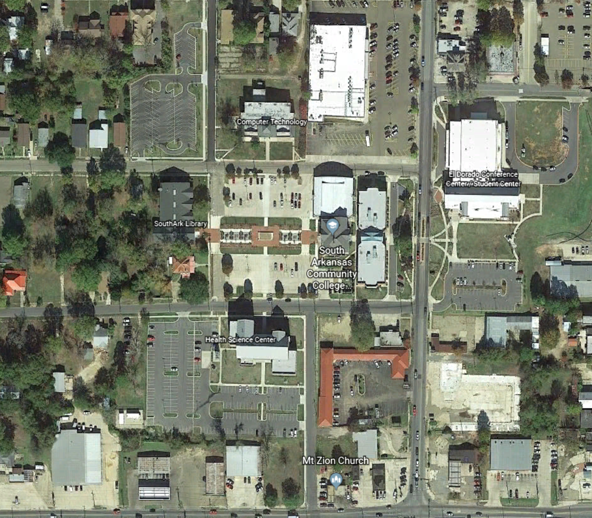

South Arkansas Community College
East Campus
3696 East Main
El Dorado Ar

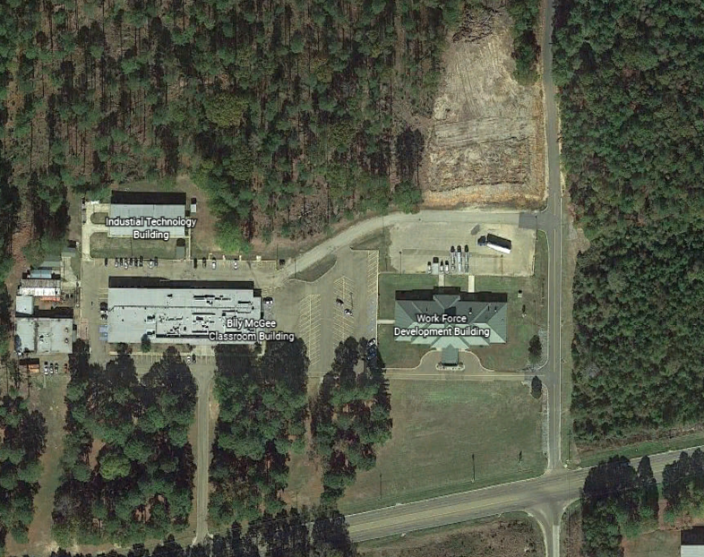
Bradley County Health Unit
SouthArk Warren Campus
208 North Bragg Street
Warren, AR

Warren Campus located in the Bradley County Health Unit.

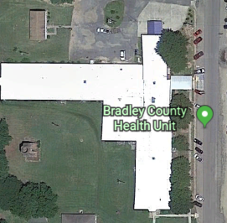
South Arkansas Arboretum
1506 Mount Holly Rd.
El Dorado, AR
South Arkansas Arboretum: Weddings, Reunions, Parties, Pick Nicks, etc.; as schedule through the office of the El Dorado Conference Center

